**Excel Assignment 1**

1. **What is Excel? Why do we use Excel?**

Excel is a spreadsheet application created and distributed by Microsoft. It is essential for the Microsoft Office set-up of efficiency programming.

Usage:

1. MS Excel is used popularly for calculations.
2. Budget plans, forecasts, expense tracking can be done using Excel.
3. You can visualize your data and gain insights with Excel by creating different charts and graphs with Excel.
4. Excel allows keeping employees and business owners organized and on top of their inventory.
5. You can create checklists and goal planning.
6. It is widely used in project management.
7. **List all the versions of Microsoft excel. Compare excel software provided from multiple vendors**.

There have been **30 different versions** of Excel, stretching from 1985 to the present day. These days most users today will have Excel 2016, 2019, 2021 or 365.

To open two Excel files side by side, do the following:

1. Open the workbooks you want to compare.
2. Go to the *View* tab, *Window* group, and click the **View Side by Side** button.
3. **How to create bar charts in excel, demonstrated with practical examples.**

Bar charts in excel are useful in the representation of the single data on the horizontal bar. They represent the values in horizontal bars. In these charts, categories are displayed on the Y-axis and values are displayed on the X-axis. To create or make a bar chart, a user needs at least two variables called independent and dependent variables.

Independent Variable: This doesn’t change with respect to any other variable.

Dependent Variable: This change with respect to the independent variable.

Mainly there are three types of bar charts in excel.

#1 – Stacked Bar Chart: It is also referred to as the segmented chart. It represents all the dependent variables by stacking together and top of other variables.

#2 – Clustered Bar Chart: This chart groups all the dependent variables together to display in a graph format. A clustered chart with two dependent variables is referred to as the double graph.

#3 – 3D Bar Chart: This chart represents all the dependent variables in 3D representation.

Excel-Bar-Chart

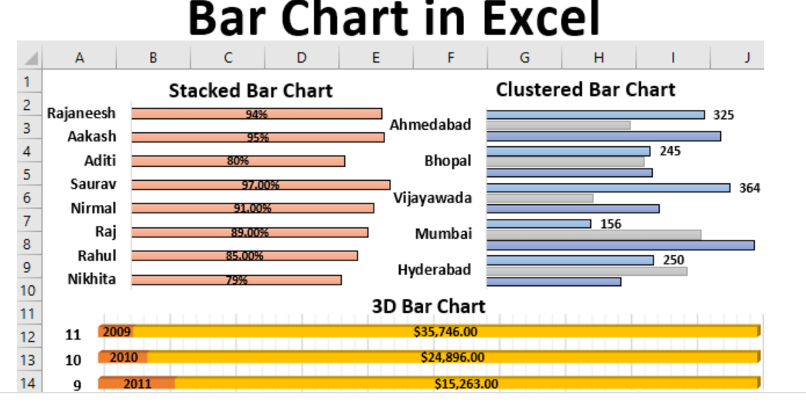

1. **How to connect Excel with the databases.**

To connect Excel to a database in SQL Database, open Excel and then create a new workbook or open an existing Excel workbook. In the menu bar at the top of the page, select the Data tab, select Get Data, select From Azure, and then select From Azure SQL Database.